Holiday Bible Club!
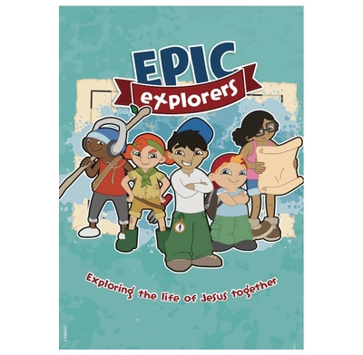
Mortimer Hall, Old Marston
Wed 25 Oct and Thurs 26 Oct
9.30 am to 12.30 pm
Games • Food • Bible stories • Crafts

- The club is for children in primary school.
Younger children are welcome, if a parent or carer can stay with them.
- Refreshments provided
- Bring and Share lunch on Thursday for children, parents and carers
- Epic Explorers service on Sunday 29 October,
10.30 am at St. Michael’s Primary School

Please book your place by 18 October.
Go to themnc.org or
return the registration form or
phone Helen on 203779.

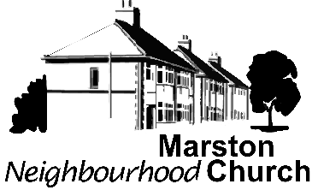

Epic Explorers registration form
If you would like your child(ren) to attend the Epic Explorers club, please go to themnc.org or fill in the details below and deliver to Helen at
92 Oxford Road, Marston, Oxford, OX3 0RD.

Child(ren)’s Date(s) School
Name(s) of birth year(s)

Address:

Telephone number:
Contact in case of emergency (name and phone number):

Second contact in case of emergency (name and phone number):

Special needs including allergies and medication:

Permission for child to be in publicity photos: yes / no
I hereby give permission for my child(ren) listed overleaf to take part in activities at Mortimer Hall, and I give my consent for medical treatment or first aid arising out of illness or accident.

Signed: Date:

